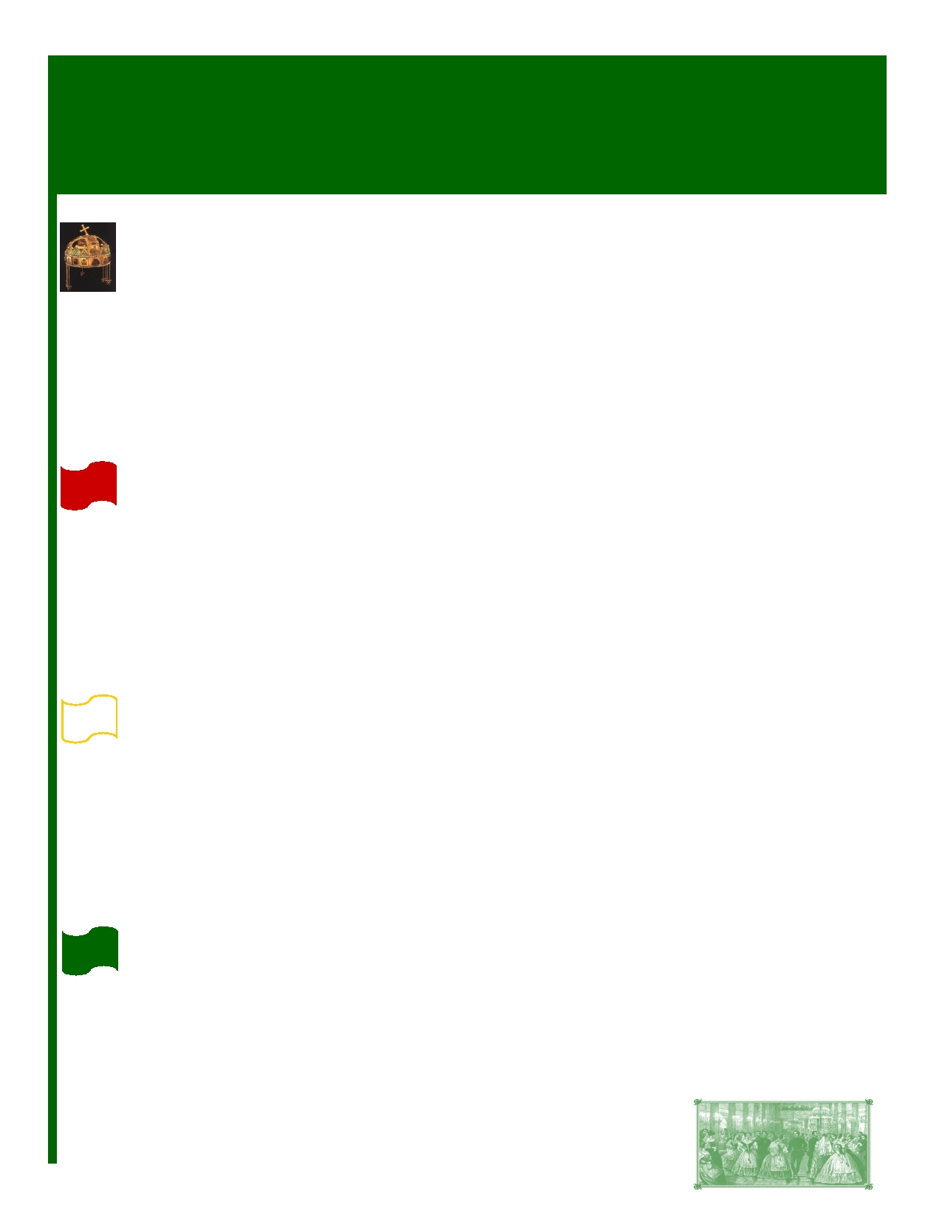
6 9th H E L I C O N B A L L
CORPORATE SPONSORSHIP OPPORTUNITIES

Crown (Korona) Sponsor - $2,000+
As our Korona Sponsor, you will receive:

→ Recognition on dedicated signage posted in the general Champagne Reception at the 69th Helicon Ball
→ Corporate logo (provided by you) printed on half a page in black & white in the sponsorship pages of the
souvenir Ball Program
→ Up to four (4) tickets to the 69th Helicon Ball
→ Inclusion in a recognition advertisement in the Toronto-based Hungarian newspapers
→ Mention on the Helicon Society's website, including your corporate logo, company name and link to your
website (effective once your sponsorship is received and remains up for 12 months after the Ball).

Red (Piros) Sponsor - $1,000
As a Piros Sponsor, you will receive:

→ Recognition on signage posted in the general Champagne Reception at the 69th Helicon Ball
→ Corporate logo (provided by you) printed on a quarter page in black & white in the sponsorship pages of the
souvenir Ball Program
→ Two (2) tickets to the 69th Helicon Ball
→ Inclusion in a recognition advertisement in the Toronto-based Hungarian newspapers
→ Mention on the Helicon Society's website, including your corporate logo, company name and link to your
website (effective once your sponsorship is received and remains up for 12 months after the Ball).

White (Fehér) Sponsor - $500
As a Fehér Sponsor, you will receive:

→ Recognition on signage posted in the foyer at the 69th Helicon Ball
→ Corporate logo (provided by you) printed on one eighth of a page in black & white in the sponsorship pages of
the souvenir Ball Program
→ One ticket to the 69th Helicon Ball
→ Inclusion in a recognition advertisement in the Toronto-based Hungarian newspapers
→ Mention on the Helicon Society's website, including your corporate logo, company name and link to your
website (effective once your sponsorship is received and remains up for 12 months after the Ball).

Green (Zöld) Sponsor - up to $300
As a Zöld Sponsor, you will receive:

→ Corporate logo (provided by you) printed on one line in black & white in the sponsorship pages of the souvenir
Ball Program
→ Inclusion in a recognition advertisement in the Toronto-based Hungarian newspapers
→ Mention on the Helicon Society's website, including your company name and link to your website (effective
once your sponsorship is received and remains up for 12 months after the Ball).

Page 1


6 9th H E L I C O N B A L L - CORPORATE SPONSORSHIP OPPORTUNITIES

Corporate Table - $2,000
As a Corporate Table Sponsor, you will receive:

→ Corporate logo (provided by you) printed in black & white on the sponsorship page of the souvenir Ball Program
→ Eight (8) tickets to the 69th Helicon Ball
→ Inclusion in a recognition advertisement in the Toronto-based Hungarian newspapers
→ Mention on the Helicon Society's website, including your company name and link to your website
(effective once your sponsorship is received and remains up for 12 months after the Ball).

In-Kind Donations
We are seeking in-kind donations for the following items:
Gifts for Debutantes (approx. 10)
Gifts for Palotás Dancers (approx 10 men and 10 women)
Prizes to be given away at our midnight prize draw

As an In-Kind Donor, you will receive:
→ Corporate logo (provided by you) printed in black & white on the sponsorship page of the souvenir Ball Program
→ Mention on the Helicon Society's website, including your company name and link to your website (effective
once your sponsorship is received and remains up for 12 months after the Ball).

All Sponsors - Please note:
◻ Sponsors will be listed in the program under the applicable sponsorship category.
◻ Sponsors will be listed in the order that their sponsorship is received (not in alphabetical order).
◻ Charitable tax receipts will not be issued for sponsorship amounts, as the sponsorship will result in material
advantage in return for the sponsor in the form of promotion or advertising, as per the guidelines of the Canada
Revenue Agency. For taxation purposes, the sponsor may be able to claim the contribution as an advertising expense.
◻ Sponsorship packages may be subject to change.

Contact: Tom Gauder
416 707 6876
Email: theball@heliconsociety.com

Page 2

